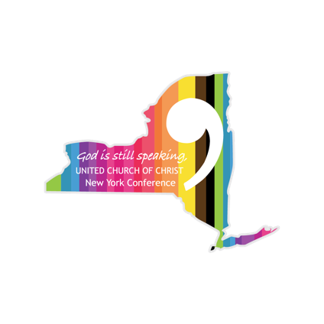
2024 Standing Rules of the Annual Meeting
New York Conference of the United Church of Christ

- Voting members must sign in as delegates at the time of registration. Voting information will be given before each vote is taken. Quorum will be determined by members present and registered. All proceedings of the annual meeting shall, unless otherwise provided for, be governed by the latest edition of Robert’s Rules of Order.

- No other business than that on the program as presented and adopted by the delegates, or other business as may logically emanate from it, will be considered, unless it is first presented to the Business Committee for consideration and recommendation to the Conference.

- No delegate may speak more than twice to the same subject and the first speech shall be limited to two minutes and the second speech to one minute.

- If a delegate wishes to speak to a subject, she/he/they must obtain permission from the meeting moderator to make his/her/their presentation and identify themself and their stance on the subject (pro or con) before speaking. Discussion will be terminated by the Chair when one point of view becomes vacant but can be reopened by a 2/3 vote.

- Any amendment to motion which, in the opinion of the Chair, substantially changes the force or intent of the motion shall be declared out of order until submitted to and approved by the Business Committee as a new motion.

- All motions approved by the Business Committee for action must be distributed to the delegates in writing not less than four hours before coming to the floor for debate.

- All motions and principal amendments (other than editorial) must be presented to the Moderator and/or Secretary in writing at the time of introduction.

- When voting, delegates must be present.

- Visitors shall have the privilege of the floor with voice but without vote and shall be subject to the same rules as apply to the delegates.

